Use-Case Realization Report
Delete Lesson

Issue <1.0>
Revision History
Date | Issue | Description | Author
<dd/mmm/yy> | <x.x> | <details> | <name>

Table of Contents
1. Brief Description 4
2. Flow of Events 4
3. Interaction Diagrams 4
3.1 Collaboration Diagram for Delete Lesson 4
4. Participating Objects 5
5. Class Diagrams 5
5.1 Class Diagram for Delete Lesson 5
6. Derived Requirements 6

Use-Case Realization Report
Delete Lesson

Brief Description

Flow of Events

Standard Flow
- Portal Admin selects the lessons to be deleted, and click “delete” button
- Lesson Controller deletes the lessons selected.
- Lesson Controller deletes the lesson sections consisting of the deleted lessons.
- Lesson Controller updates the lesson modules, and mark the lessons deleted.

Interaction Diagrams

Collaboration Diagram for Delete Lesson
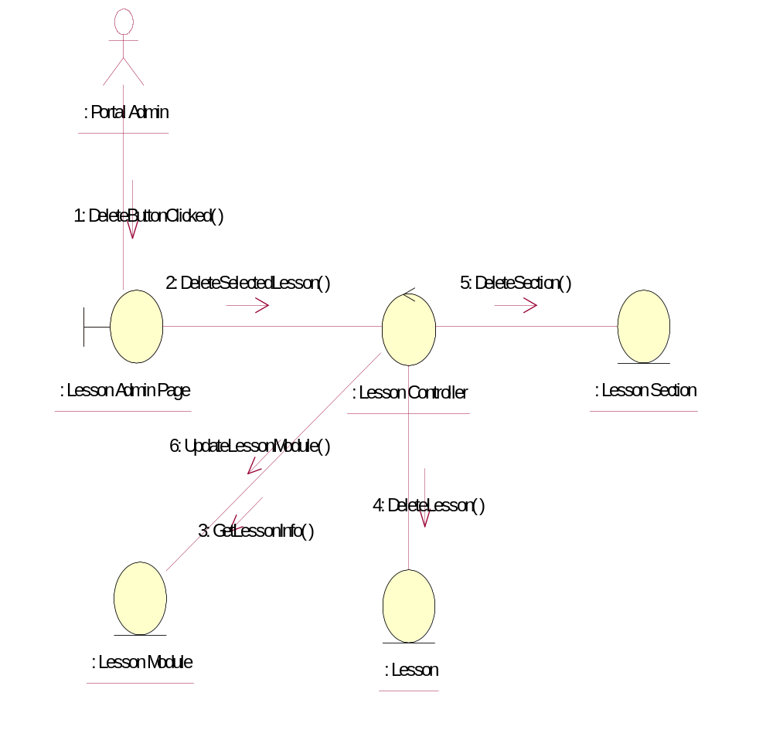

Participating Objects
: Lesson
This entity is the lesson object, it belongs to JMD.
: Lesson Admin Page
This is the page for adding, deleting, modifying lessons.
: Lesson Controller
This is the controller to upload, add, delete and modify lessons.
: Lesson Module
This is the object containing the lesson info.
: Lesson Section
This entity is the Section object, it belongs to JMD.
: Portal Admin
This is the super user of the system.

Class Diagrams

Class Diagram for Delete Lesson
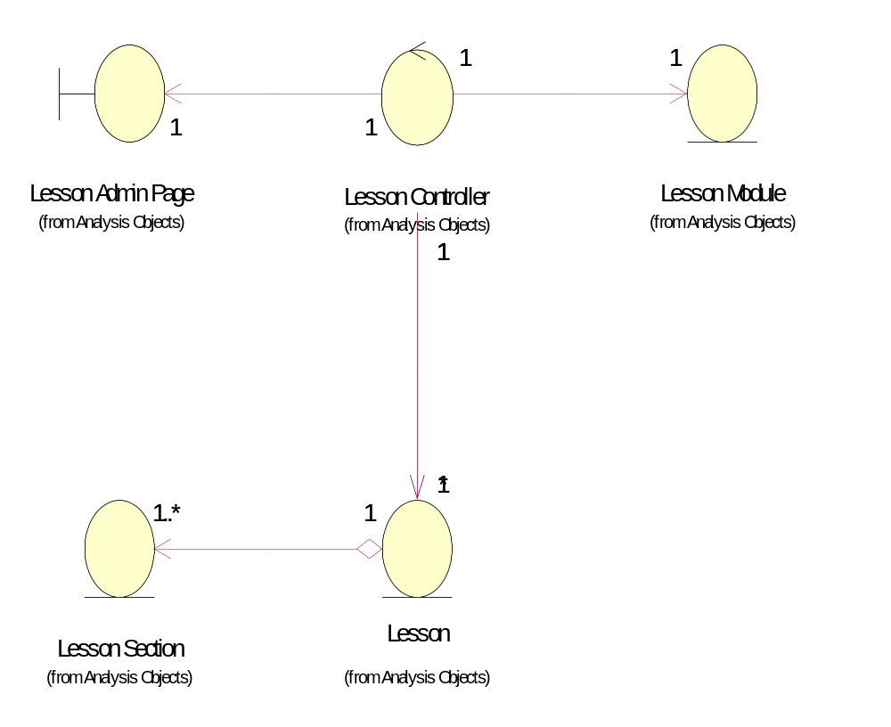

Derived Requirements
[enter the derived requirements here]

